Understanding Active Radar Search and Track Systems: A Simplified Approach

Jacob C Wilkerson

Missouri University of Science and Technology

English 1120: Exposition and Argumentation

Edrina Adjei-Manu

March 18, 2025

Understanding Active Radar Search and Track Systems: A Simplified Approach

Radar technology plays a vital role in our daily lives, even if we don’t always notice it. From air traffic control ensuring safe flights to weather systems predicting storms, radar is everywhere. For incoming freshmen in engineering and technology fields, understanding radar—especially Active Radar Search and Track Systems (ARSTS)—provides a foundation for exploring careers in aviation, defense, and even space exploration. Whether it is used to monitor incoming aircraft, detect enemy threats, or track weather patterns, radar remains a crucial technological advancement. This blog post breaks down radar systems into simple concepts, helping you grasp their importance and real-world applications.

# What is Radar?

At its core, **radar** (short for "Radio Detection and Ranging") is a system that uses radio waves to detect objects and measure their distance, speed, and direction. The technology works by emitting short bursts of radio waves that travel through the air. When these waves hit an object, they bounce back to the radar receiver. By analyzing the time taken for the waves to return, the system determines the object's location. This process allows radar systems to function effectively in environments where human vision is unreliable, such as at night or in adverse weather conditions like fog or heavy rain.

One key feature that enhances radar's capabilities is the **Doppler effect**, which measures the speed and direction of objects based on changes in the frequency of reflected waves ([National Weather Service, n.d.](https://www.weather.gov/mkx/using-radar)). When an object moves toward the radar, the frequency of the reflected wave increases, whereas it decreases when the object moves away. This frequency shift allows radar systems to determine not only an object's location but also its velocity, making it an invaluable tool in aviation, defense, and meteorology.

# Active vs. Passive Radar Systems

Understanding the difference between **active** and **passive** radar systems helps highlight why ARSTS are so valuable. Passive radar systems do not emit their own signals; instead, they rely on existing radio waves from sources like TV or radio broadcasts. These systems are harder to detect because they do not generate their own emissions, making them useful in stealth applications. However, their range and accuracy are limited, making them less effective in situations requiring precise tracking.

On the other hand, active radar systems emit their own radio waves, allowing for greater control over detection and tracking. This makes them more reliable for applications like military defense, air traffic control, and maritime navigation ([Congressional Research Service, 2020](https://www.congress.gov/crs-product/R46564)). Because active radar systems send out signals and analyze their return, they provide real-time information about moving objects, making them essential in scenarios that require constant surveillance and fast decision-making.

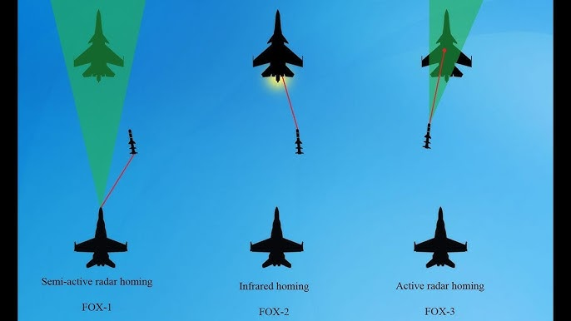

(YouTube) pictured above is a f/a-18 firing a missile at a SU-33 or SU-30. This diagram shows that a simi active and active radar systems (FOX-1 and FOX-3 (Air Land Sea Space Application Center, 2023)) use reflected radar waves to find and track a target, meanwhile inferred systems (FOX-2 (Air Land Sea Space Application Center, 2023)) use emitted infrared rays to find and track a target.

# Key Components of Active Radar Search and Track Systems

ARSTS consists of three main components: the transmitter, receiver, and tracking system. The transmitter sends radar pulses that travel at the speed of light and reflect off objects. These pulses are typically high-frequency signals designed to cover long distances. The receiver detects these reflected signals and calculates the object's distance based on the time delay between transmission and reception. Advanced radar systems can even filter out unwanted noise to improve accuracy. The tracking system then processes this data using sophisticated algorithms to monitor an object’s movement over time, refining measurements for precision.

# The Role of the Doppler Effect

The Doppler effect enhances ARSTS by measuring frequency shifts in reflected radio waves. When an object moves toward the radar, the frequency increases; when it moves away, the frequency decreases. This helps determine object velocity, crucial for tracking fast-moving targets like aircraft and missiles. Without the Doppler effect, radar systems would struggle to distinguish between stationary and moving objects, reducing their effectiveness in high-speed environments.

In aviation, the Doppler effect ensures safe air traffic management by detecting the speed of approaching and departing aircraft. In military defense, it helps guide missile systems and intercept threats by calculating the precise movement of enemy aircraft. In weather monitoring, it detects storm patterns and tornadoes by tracking wind speeds and atmospheric shifts. The ability to measure velocity makes radar systems indispensable for real-time decision-making in these fields.

# Applications of ARSTS

## Aviation

Air traffic controllers use ARSTS to monitor aircraft positions, preventing collisions and guiding planes safely through crowded airspace. By continuously tracking multiple aircraft, radar systems help pilots navigate efficiently and avoid hazardous conditions.

## Military & Defense

ARSTS track enemy aircraft and missiles, playing a key role in national security. Modern missile defense systems rely on radar to detect and neutralize threats before they reach their targets. The ability to track multiple objects simultaneously gives military forces a significant strategic advantage.

## Weather Monitoring

Meteorologists use ARSTS to detect storms and severe weather, providing early warnings that save lives. Radar systems allow forecasters to track hurricanes, thunderstorms, and tornadoes, giving communities time to prepare for extreme weather events.

## Maritime Navigation

Ships rely on ARSTS to detect other vessels, reducing the risk of collisions in busy ports or open water. Radar helps navigators safely maneuver through fog, darkness, and rough seas, ensuring the safety of cargo and passengers.

## Law Enforcement

Police use radar systems to track vehicle speeds, enforcing traffic laws and improving road safety. Speed detection radar is widely used to monitor highways and urban areas, helping to reduce accidents caused by reckless driving.

# Why This Matters to You

Whether you’re an engineering student or simply curious about technology, understanding radar systems opens doors to numerous career opportunities. ARSTS play a vital role in safety, security, and technological advancement. If you're considering a career in aviation, defense, or smart technology, mastering radar principles will give you a competitive edge. As radar technology continues to evolve, its applications will only expand, making it an exciting and essential field to explore.

References

Air Land Sea Space Application Center. (2023, August 26). MULTI-SERVICE TACTICS, TECHNIQUES, AND PROCEDURES FOR MULTI-SERVICE BREVITY CODES. Air Land Sea Space Application Center.

Product details r46564 - CRS reports - congress.gov. (n.d.). https://crsreports.congress.gov/product/details?prodcode=R46564

Richards, K. (n.d.). Radar basics. https://training.weather.gov/nwstc/NEXRAD/RADAR/Section1-2.html

US Department of Commerce, N. (2018, December 18). *Using and understanding Doppler radar*. National Weather Service. https://www.weather.gov/mkx/using-radar

YouTube. (n.d.). YouTube. https://www.youtube.com/watch?app=desktop&v=eXWbi6FV2Ic&t=3s

*For additional information on APA Style formatting, please consult the* [*APA Style Manual, 7th*](https://apastyle.apa.org/style-grammar-guidelines) *Edition.*